ATSIKANA PAULENDO PRIVATE SECONDARY SCHOOL

2021 MALAWI SCHOOL CERTIFICATE MOCK EXAMINATIONS

BIOLOGY
Subject Number: M022/II
Wednesday 25th April 2018 Time Allowed: 2Hrs Sessions
7: 30 am onwards
PAPER II (40 marks)

Practical
Instructions
Question  number | Tick if  Answered | Do not write in these columns
1
2
3
1. This paper contains 6 pages. Please check.

2. Write your Examination number at the top of this page and of every sheet.

3. Answer all the three questions in the spaces
provided on this paper. The maximum number
of marks for each question is indicated against
each question. A pencil should be used for all
drawings.

4. In the table provided on this page, tick against
the question number you have answered.

1. You are provided with specimens X and Y, scalpel , salt solution and distilled water in beakers labeled A, B and C as follows:
A: Air
B: 30% salt solution
C: Distilled water
Cut specimen X into three strips of lengths 40 mm each and then place each of the three strips in the test beakers. Then leave the step-ups for 20 minutes and then make observations. Use the information to answer the questions that follow:
a. In which beaker was;
(i). greatest increase in length of strips:
_____________________________________________________(1 mark
(ii) least increase in length of strips:
_____________________________________________________(1 mark)
(iii) No change in length of strip:
________________________________________________________(1 mark)
b. Record the results after the experiment in a table below:

 | Strip left in air | Strip in 30% salt solution | Strip in distilled water
Length in mm
Average length (mm)

Flexibility
(6 marks)
c. Give a reason for the change in:
A: _________________________________________________(1 mark)
B: _________________________________________________(1 mark)
C: _________________________________________________(1 mark)
d. What was the reason for including sample A in this experiment?
________________________________________________________(1 mark
e. What process do the plants use to gain or lose water from or to the surrounding?
________________________________________________________ (1mark )
f. Place strip dipped in beaker A on the white tile and cut it down the middle lengthwise into two separate parts using the scalpel. Apply one or two drops of dilute iodine solution to one of the cut surfaces.
(i) Describe the results obtained
____________________________________________________________________________________________________________________________________________(1 mark)
(ii) What conclusion can you make from these results?
______________________________________________________________________________________________________________________________________________(1 mark)
g. (i) What storage organ of food does specimen Y use?
________________________________________________________(1 mark)
(ii) Explain how the food stored in the organ mentioned in 1g(i) is used by specimen Y _____________________________________________________________________________________________________________________(1 mark)
(iii) State any one nutrient that can be obtained from specimen Y
_______________________________________________________(1 mark)
(iv) Name the type of root system for specimen Y
______________________________________________________(1 mark )
(v) Using the knife cut specimen Y longitudinally and label any three parts

(3 marks)

2 . You are provided with specimen H, scalpel and hand lens.
Use the scalpel to make the transverse section of the specimen H smooth.
(a) With the use of hand lens observe the internal parts of specimen H. Draw the transverse section of specimen H and label any three parts.

(3 marks)
(b) Describe the distribution of tissues in (a) above
_______________________________________________________________________________________________________________________________________________(1 mark)
(c) What type of stem is related to the distribution of tissues in (a) above?
___________________________________________________________________(1 mark)
3. A group of students collected snails from the school pond. The shells were measured accurately and the results were recorded as shown below.
Size of snails (mm)

5 | 14 | 17 | 9 | 21 | 19 | 25 | 27 | 33 | 34 | 30
18 | 6 | 7 | 16 | 11 | 22 | 23 | 23 | 26 | 29 | 31
8 | 19 | 9 | 18 | 15 | 13 | 17 | 29 | 22 | 27 | 25
12 | 16 | 10 | 11 | 21 | 24 | 25 | 28 | 19 | 21 | 24
19 | 25 | 20 | 23 | 23 | 28 | 20 | 20 | 10 | 15 | 23
21 | 28 | 22 | 26 | 21 | 27 | 30 | 18 | 7 | 8 | 20
26 | 24 | 26 | 31 | 30 | 24 | 32 | 22 | 24 | 10 | 17

- Use the data to complete table below

Size of snail shell  (mm) | Number of snail shells
3-6
7-10
11-14
15-18
17-20
21-24
25-28
29-32
33-36
3 Marks
b. What type of variation is shown by the results?
_____________________________________________________________1 Mark
c. Suggest two reasons for the variations in the snail shell size.
i. _______________________________________________________(1mark)
ii. ______________________________________________________(1 mark)
  - Use the results obtained in the table to plot a bar graph of the number of snails against shell size.

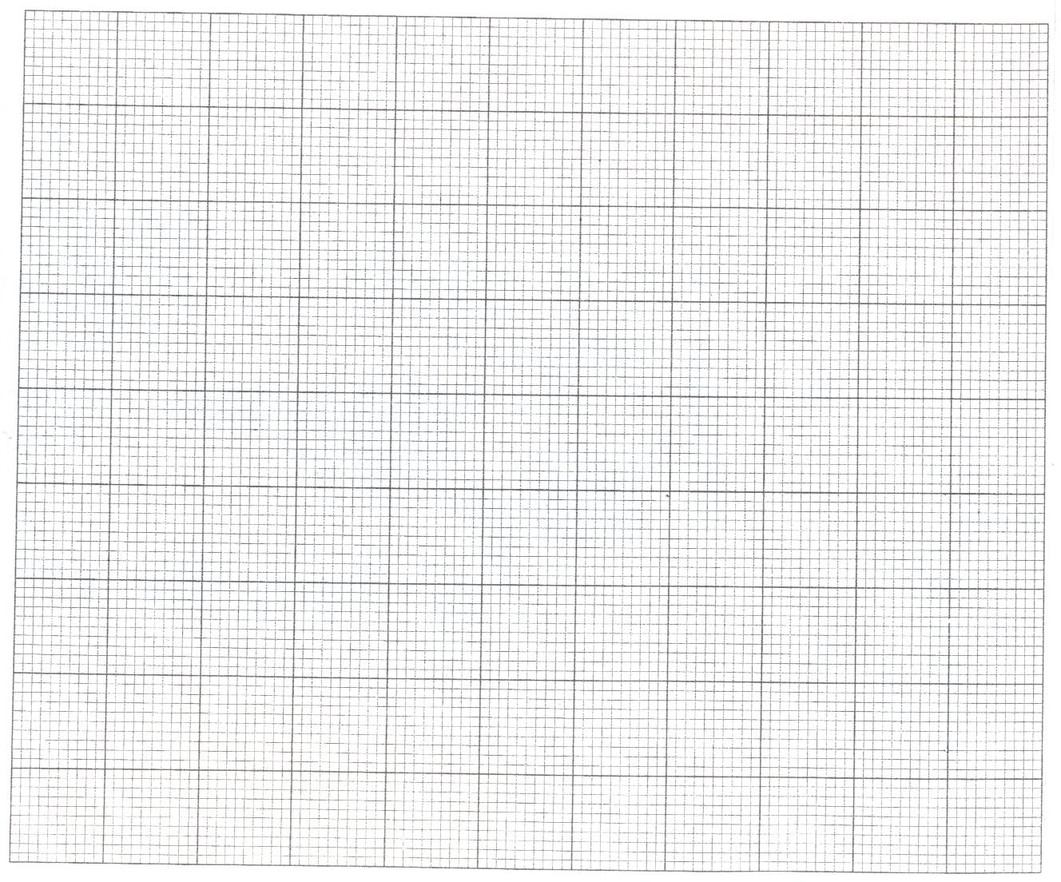

(6 marks)

END OF QUESTION PAPER

